Super Dvora Mk III
Arneson Control System(ACS)
A Case Study of rectifying communication defects in ACS System
BY : LT (IT) DSAAS Gunashinghe
7/19/2013
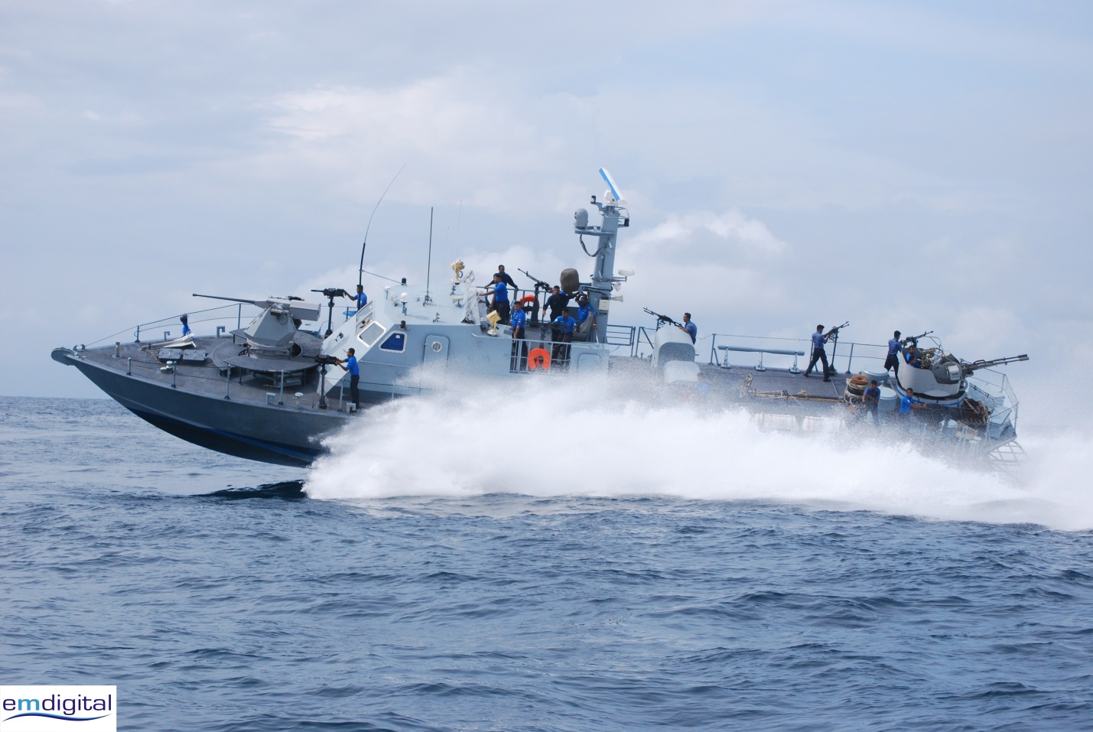
Table of Contents
List of Acronyms and Abbreviations 2
Introduction: 2
Background: 2
ACS defects Summary in 444 Series 3
My Experience: 4
Arneson Control System 4
Introduction 4
ACS system structure and block diagram 4
ACS System Structure 5
Control Area Network (CAN) Bus 7
Topology 7
Data Frame 8
How does monitor CAN use PC application? 9
Diagnosis Step followed myself to rectify the above defects 9
Future Trends 11
ACS Controller Using Micro Controller 11
Conclusion 11

List of Acronyms and Abbreviations

ACS : Arneson Control System
ASD : Arneson Surface Drive
PID : Proportional Integral Differential
BIT : Built In Test
SCC : Solenoids/Steering Control Card
ICT : In Cylinder Transducer
EICT : Electronics in Cylinder Transducer
FU : Follow-Up
NFU : Non Follow-Up
PWM : Pulse Wave Modulation
CAN : Controlled Area Network
STB : Starboard
N.C : Not Connected
VM : Voltage Module

Introduction:
The document is prepared on the basis of study done in rectifying defects in ACS in P444 Series of Supper Dovra MK III .

Background:
P444 Series of Super Dvora MK III joined SLN fleet on 01st April 2010. Currently SLN fleet has 6 no’s of Super Dvoras .
Name | Date of Join to SLN fleet | Location
P4442 | 01st April 2010 | East
P4443 | 18th July 2010 | West
P4444 | 24th September 2010 | East
P4445 | 08th November 2010 | East
P4446 | 16 March 2011 | East
P4447 | 25th February 2011 | West

P 4445 which joined on 08th November 2010, developed a defect in steering which non synchronizing of propeller movement with the wheel moment (Error message popped up as “System encountered an uncorrectable hardware error”)

ACS defect Summary in 444 Series
Craft | Defect | Date | DTG
P442 | AL-RCL Speed demand defect appear on blue vision system | 19/06/2010 | 191258
P442 | Intermittent failure of ACS control System | 04/04l2011 | 417080411
P442 | ACS Shutdown three times | 18/08/2011 | 181818
P442 | ACS PC malfunction | 27/09/2011 | 2618280911
P442 | ACS PC malfunction indicating CAN1 & CAN 2 communication error | 09/11/2011 | 913081111
P442 | Malfunction of ACS System | 27/11/2011 | 2718581111
P442 | ACS System SCC steering card defective | 10/09/2012 | 101123
P4443 | CAN 1 & CAN 2 Error switched to NFU alarm whilst operating at pier | 16/03/2011 | 1617080311
P4443 | ACS Malfunction with written displays | 03/11//2011 | 221181111
P4443 | ACS Computer Frozen three times during last patrol | 18/12/2011 | 181518
P4443 | Blue-vision malfunction | 28/02/2012 | 2816580212
P4443 | AL GCU =211 A 002 – A 030 Faulty | 31/10/2012 | 3117581012
 | Alarm appearing continuously  i. AL GCU=211+A002-A030 Faulty  ii. AL ECU Error/check error code  iii. AL RCL combined alarm | 7/12/2012 | 71448
 | CAN 1 & CAN 2 communication error indicating continuously in ACS display and struck in non-follow up mode | 21/12/2012 | 212481212
P4444 | ACS control System PC restart intermittently | 25/05/2011 | 2521080511
 | ACS System follow up mode defective | 08/06/2012 | 815380612
P445 | Unable to start STBD M/E | 23/12/11 | 2316021211
 | ACS Defective | 21/09/2012 | 212001
P4446 | Unable to switch ON ACS computer | 08/08/2011 | 81520
 | Unable to boot up blue vision system | 26/04/2012 | 2617010412
P4447 | Unable to start ACS computer | 11/04/2012 | 111638

My Experience:
I would like to mention that I have observed the above defect from P 4445 when I was serving as an officer under trainee during the second session of the sea training. During the period of training, I observed that error message on ACS System repeatedly and I was instructed by OIC to investigate the matter. I would like to brief on ACS System with the experience I gained during this investigation.

Arneson Control System

Introduction
The ACS is an innovative craft/ship digital steering and trim control system based on the well-known Arneson Surface Drive (ASD) system. The system uses state of the art hardware and software technology to implement PID (Proportional Integral Differential) control algorithm to drive and control the craft propellers.

ACS system structure and block diagram

The main parts of the ACS system are:

- Two control panels (which are also uses as displays)
- An industrial PC
- An Adaptors box
- An SCC (Solenoids Control Card) box
- Steering wheels
- Three dual proportional solenoids
- Four Electronic In Cylinder Transducer (EICT)

ACS System Structure
Figure: 1.1
(Source: ACS _User Manual_Rev-A.pdf)

Figure: 1.2

(Source: ACS _User Manual_Rev-A.pdf)

This diagram is described about the component of ACS System.

- USB_CAN and USB_NMEA use for connecting PC and ADAPTORS BOX.
- CAN-1 and CAN-2 used for connecting control station and ACS Application.
- CAN-1 SOLENOID and CAN-2 SOLENOID use for transfer control signal from Adaptors Box to SCC BOX.
- GPS connect to Adaptors Box for feed location and application received location data through adaptor box (You have to configure port by selecting dip switches inside adaptor box)

Note: -
Here use 2 CAN bus one work as active and other one use as redundancy.

Control Area Network (CAN) Bus
Figure: 1.3
(Source:www.eecs.umich.edu/eecs/courses/eecs373/Lec/.../373CANpreso.pdf‎)
CAN bus is a message-based protocol, designed specifically for automotive applications but now also used in other areas such as aerospace, industrial automation and medical equipment.
CAN bus (ISO 11898-1:2003) originally specified the link layer protocol with only abstract requirements for the physical layer, e.g., asserting the use of a medium with multiple-access at the bit level through the use of dominant and recessive states. The electrical aspects of the physical layer (voltage, current, number of conductors) were specified in ISO 11898-2:2003, which is now widely accepted. However, the mechanical aspects of the physical layer (connector type and number, colors, labels, pin-outs) have yet to be formally specified. As a result, an automotive electronic control unit (ECU) will typically have a particular—often custom—connector with various sorts of cables, of which two are the CAN bus lines. Nonetheless, several de facto standards for mechanical implementation have emerged, the most common being the 9-pin D-sub type male connector with the above pin-out.

Topology
This de facto mechanical standard for CAN could be implemented with node having both male and female 9-pin D-sub connectors electrically wired to each other in parallel within the node. Bus power is fed to a node's male connector and the bus draws power from the node's female connector. This follows the electrical engineering convention that power sources are terminated at female connectors. Adoption of this standard avoids the need to fabricate custom splitters to connect two sets of bus wires to a single D connector at each node. Such nonstandard (custom) wire harnesses (splitters) that join conductors outside the node reduce bus reliability, eliminate cable interchangeability, reduce compatibility of wiring harnesses, and increase cost.
Figure: 1.4
(Source:www.eecs.umich.edu/eecs/courses/eecs373/Lec/.../373CANpreso.pdf‎)

The absence of a complete physical layer specification (mechanical in addition to electrical) freed the CAN bus specification from the constraints and complexity of physical implementation. However it left CAN bus implementations open to inter-interoperability issues due to mechanical incompatibility.

Data Frame

A CAN network can be configured to work with two different message (or "frame") formats: the standard or base frame format (described in CAN 2.0 A and CAN 2.0 B), and the extended frame format (only described by CAN 2.0 B). The only difference between the two formats is that the "CAN base frame" supports a length of 11 bits for the identifier, and the "CAN extended frame" supports a length of 29 bits for the identifier, made up of the 11-bit identifier ("base identifier") and an 18-bit extension ("identifier extension"). The distinction between CAN base frame format and CAN extended frame format is made by using the IDE bit, which is transmitted as dominant in case of an 11-bit frame, and transmitted as recessive in case of a 29-bit frame. CAN controllers that support extended frame format messages are also able to send and receive messages in CAN base frame format. All frames begin with a start-of-frame (SOF) bit that denotes the start of the frame transmission.
Figure: 1.5
(Source:www.eecs.umich.edu/eecs/courses/eecs373/Lec/.../373CANpreso.pdf‎)

CAN have four frame types:
- Data frame: a frame containing node data for transmission
- Remote frame: a frame requesting the transmission of a specific identifier
- Error frame: a frame transmitted by any node detecting an error
- Overload frame: a frame to inject a delay between data and/or remote frame

How does monitor CAN use PC application?

Here we can use Can Status window or following tool for check communication.
Figure: 1.6
(Source: ACS _User Manual_Rev-A.pdf)

Ref: http://www.canviausb.com/CANviaUSB

Diagnosis Step followed myself to rectify the above defect

- Check Physical communication CAN-1 and CAN-2
  - As per fig 1.2 and 1.1 check physical connectivity by ensure plug connector
- Listen Can port by using USB CAN application (ref : fig 1.6)
  - Start application.
  - Open communication log
  - Check data transmitting and receiving.
- Re check CAN Card drivers.
  - Still not transmitting or receiving data re install card driver.
  - Restart ACS PC.
  - Check data transmitting and receiving.

- Still not working
  - reinstall PCANBasic.dll ( Some time it will corrupt)
b. Restart ACS PC.
c. Check data transmitting and receiving.

- Reinstall .net Framework
- Re install ACS System.
- Check speed value is 0,
  - IF not check GPS connection.
  - GPS need to configure with correct port from ADPA control box.

Future Trends
By looking at previous defects and no occurrence PC is not suitable for such environment because of pitching and rolling it will effect to PC hard disk directly though it mount on shock absorber. Also PC is general purpose machine it runs other process rather than ACS application. I would like to propose following module instead of ACS PC.

ACS Controller Using Micro Controller
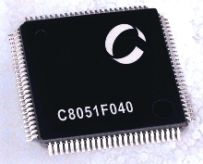

Conclusion
Arneson Control System (ACS) is developed for controlling steering system and it is a computer application developed on net framework. It passes signal through CAN bus to adaptor box and observed that failure at CAN communication and hard disk failure. I would like to propose above modification to enhance the reliability.

